Point-of-Care Ultrasound (POCUS) Training Day

27th March 2026

Hosted: Faculty from Essex Cardiothoracic Centre at Basildon Hospital

Location: SIM Suite Basildon Hospital

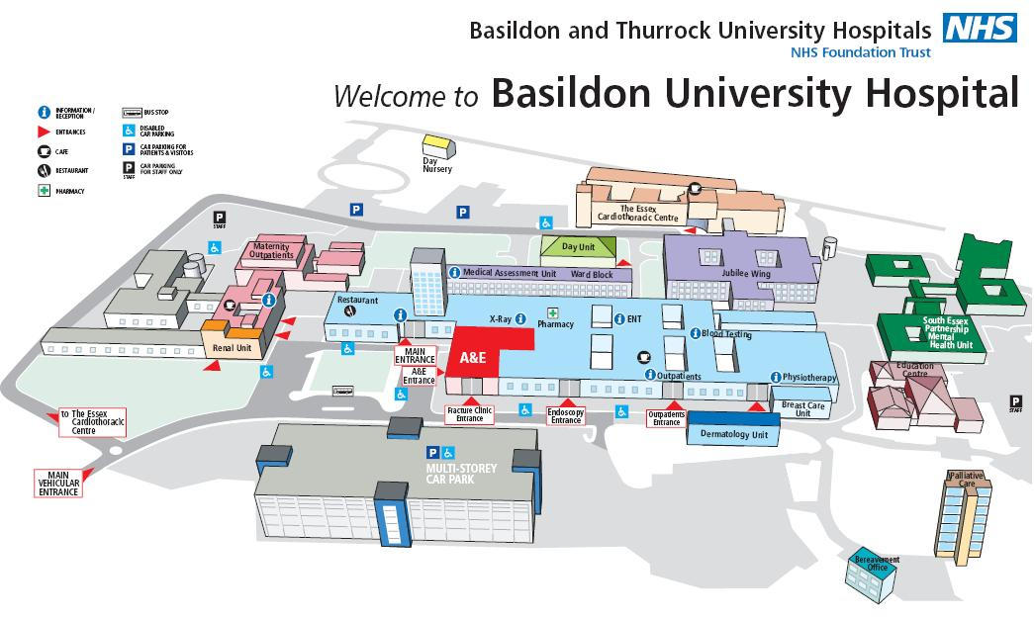

Course Fee - £100
This full-day, hands-on course provides a comprehensive introduction to point-of-care ultrasound (POCUS) with a focus on emergency and critical care applications. Designed for healthcare professionals seeking practical ultrasound skills, the program blends foundational theory with real-time scanning practice under expert guidance.
Topics cover, core principles of ultrasound physics, image optimisation, and machine operation. Clinical applications, bedside cardiac ultrasound for shock and cardiac arrest, lung ultrasound for conditions such as pneumothorax and pulmonary oedema, and the use of ultrasound in trauma through the eFAST examination.
There is a focus on ultrasound-guided procedures, including central venous access, thoracentesis, paracentesis, and peripheral nerve blocks, equipping participants with essential procedural skills applicable in high-acuity settings.

Course Programme: Application of Ultrasound in Emergency Settings
  - Comprehensive One-Day Training Itinerary
- 08:30 – 09:00 | Registration & Welcome Refreshments
Participant sign-in and informal networking
- 09:00 – 09:15 | Opening Remarks & Course Objectives
Introduction of faculty and a comprehensive overview of the day’s agenda
- 09:15 – 10:00 | Session 1: Fundamentals of Ultrasound Physics and
Machine Operation
Core principles: the properties of sound waves, probe selection, and image optimisation
Introduction to machine controls and practical demonstration of device settings – Lecturer: Dr Sali Urovi

Fundamentals of Ultrasound Physics and Machine Operation

- 10:00 – 10:45 | Session 2: Cardiac Ultrasound in the Emergency
Department
Rapid bedside echocardiography for shock, cardiac arrest, and pericardial effusion
Guided hands-on practice with standard cardiac imaging
Windows - Lecturer: Dr Maria Rita Maccaroni

Cardiac Ultrasound in the Emergency Department

- 10:45 – 11:00 | Morning Refreshment Break
Light refreshments and the opportunity for informal interaction with faculty
- 11:00 – 11:45 | Session 3: Lung Ultrasound
Diagnostic approach for pneumothorax, pleural effusion, and pulmonary oedema.
Interactive case studies and participant scanning sessions - Lecturer: Dr Tamer Montaser

Lung Ultrasound

- 11:45 – 12:45 | Session 4: Ultrasound in Trauma (eFAST Examination)
Clinical indications for emergency ultrasound in trauma
scenarios
Detailed review of the eFAST exam: focused assessment with sonography for trauma patients
Live demonstration accompanied by supervised group
Practice - Lecturer: Dr Maria Rita Maccaroni & Tamer Montaser

Ultrasound in Trauma (eFAST Examination)

- 12:45 – 13:45 | Lunch Break

- 13:45 – 14:30 | Session 5: Ultrasound-Guided Procedures
Indications and techniques for central venous catheter insertion, thoracentesis, paracentesis, and peripheral nerve blocks - Lecturer: Dr Sali Urovi

Ultrasound-Guided Procedures
- 15:15 – 15:30 | Afternoon Break
- 15:30 – 16:30 | Session 6: Case-Based Scenarios & Hands-On Skills Laboratory
Individual skills assessment with personalised faculty feedback
- 16:30 – 16:45 | Summary, Questions & Answers, and Certificate Presentation
Key summary points, further resources for continued learning
Distribution of certificates of completion to all participants

Additional Information
- All practical components are delivered under direct supervision, with access to live models.
- Participants are encouraged to contribute clinical scenarios from their own practice for group discussion.
- Comprehensive course materials and reference guides will be provided electronically.
- Support personnel will be available throughout the duration of the course for any assistance required.

