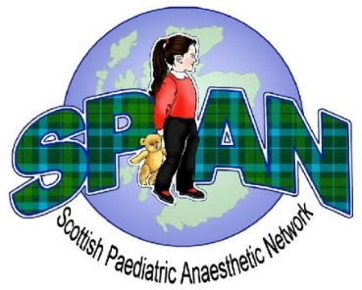
Scottish Paediatric Anaesthetic Network
Abstract Submission Guidance

What are the accepted categories of abstract?
We welcome submissions on Paediatric anaesthesia from all grades of resident trainees and medical students. Examples of abstract categories include:
- Quality Improvement
- Audit
- Original research
- Case report
- Education and training
- Survey
- Patient safety projects

What approvals and consent do I require prior to submission?
Please ensure you have appropriate local ethical/regulatory approval for your abstract submission. Presentation of patient data will need approval by one or more of the following:
- Audit Department
- R&D Department
- Trust Caldicott Guardian
- Research Ethics Committee
Written consent must be gained by the abstract author from any patient whose personal information is being used in a case report.

Is there a word limit for the abstract?
The maximum length is 300 words, excluding abstract title, authors, one table/figure and references (maximum of two).

What headings should I use for my abstract?
A general guide to structuring your abstract would include the following headings:
- Introduction
- Methods
- Results
- Discussion
- References (maximum of two)

How do I submit my abstract?
Please submit your abstract to spantraineerep@gmail.com

Can I submit more than one abstract?
Candidates are welcome to submit multiple abstracts.

Can I submit my abstract if it has been presented at another meeting?
Yes, you can still submit your abstract. We ask that you declare if your abstract has been presented at another meeting at the submission stage as we may decide to preferentially give oral presentation positions to those who have not previously presented.

Who reviews the abstracts?
All abstracts will be anonymised, assessed, and marked by the executive SPAN committee. The top scoring abstracts will be selected for oral presentation, with the remainder being offered poster presentations. Cash prizes will be awarded to the top scoring oral and poster presenters on the day of the conference.

What are the standards against which abstracts are reviewed and scored?
Abstracts are score by:
- Methodology
- Novelty/originality
- Clarity
- Significance/impact/relevance to practice

